|  |  |
| --- | --- |
| EGC_Black | Student Name \_\_\_\_\_\_\_\_\_\_\_\_\_\_\_\_\_\_\_\_\_\_\_    **Eastern Goldfields College**  Mathematics Applications U3&4 2017  Test 1 – Calculator Free1 |
|  | Total Marks: 17 marks |

**Time allowed: 10 minutes**

**No calculator or notes permitted for this section.**

***Answer all of the following questions. Show all working to obtain full marks.***

**Question 1 [3 marks]**

For each of the following sets of variables, determine if there is likely to be a relationship, and if so, identify the explanatory and response variables.

Relationship Explanatory Response

Yes/No Variable Variable

1. Basketball ability and height (cm) \_\_\_\_\_\_\_ \_\_\_\_\_\_\_\_\_\_\_\_ \_\_\_\_\_\_\_\_\_\_\_
2. Eye colour and Age (years) \_\_\_\_\_\_\_ \_\_\_\_\_\_\_\_\_\_\_\_ \_\_\_\_\_\_\_\_\_\_\_
3. Hair colour and Gender \_\_\_\_\_\_\_ \_\_\_\_\_\_\_\_\_\_\_\_ \_\_\_\_\_\_\_\_\_\_\_
4. Time spent cleaning and Size of house \_\_\_\_\_\_\_ \_\_\_\_\_\_\_\_\_\_\_\_ \_\_\_\_\_\_\_\_\_\_\_

**Question 2 [7 marks = 3, 4]**

1. Match each of the scatter graphs with the appropriate correlation coefficient from the following list of values.

**List of values: -2.3 -0.88 0.08 0.71 1.6**

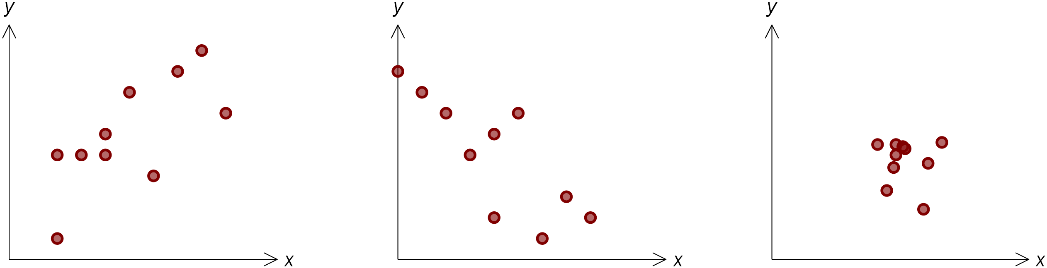

rxy = rxy = rxy =

(b) Given the following **residual plots,** comment on the appropriateness of using a linear regression model for each.

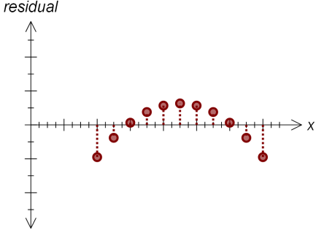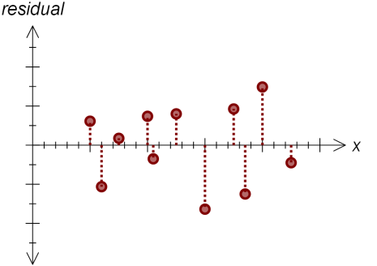

**Question 3 [5 marks = 2, 1, 2]**

The least squares regression line between *N* and *t*  is given by *N* = 0.05*t* + 2.51

1. Find the average increase in *N* corresponding to an increase of 20 units in *t.*
2. Predict the value of *N* when *t* =50.
3. The actual value of *N* when *t* = 50 is 4.95. Find the residual associated with the prediction in (b).

**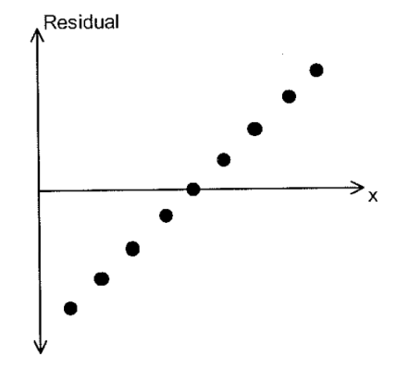Question 4 [2 marks]**

The variables *x* and *y* have a coefficient of linear correlation of 0.95. The least squares regression line of *y* = 12.4 + 0.67*x* . The residual plot associated with the least squares regression line is shown in the accompanying diagram.

Comment on the appropriateness of using the straight line model to describe the relationship between *x* and *y*.

|  |  |
| --- | --- |
| EGC_Black | Student Name \_\_\_\_\_\_\_\_\_\_\_\_\_\_\_\_\_\_\_\_\_\_\_    **Eastern Goldfields College**  Mathematics Applications 3&4 2017  Test 1 – Calculator Assumed1 |
| **Time allowed: 45 minutes** | Total Marks: 33 marks |

**One A4 page of notes IS permitted in this section.**

**Question 1 [10 marks – 1, 1, 2, 2, 2, 2]**

To investigate Year 12 student behaviour on Saturday afternoons, a group of Year 11 students conducted a survey in their school. They asked the Year 12 students “Which of the following activities would you most prefer to do on a Saturday afternoon?” Some of the results of the survey are given in the table below.

**Percentage of students choosing the various activities**

|  |  |  |
| --- | --- | --- |
| **Activity** | **Males** | **Females** |
| Watch reality television shows | 4 | 5 |
| Engage with social media | 18 | 15 |
| Play sport | 36 | 28 |
| Paid work | 29 | 30 |
| Shopping with friends |  | 22 |

(a) Enter the missing data value.

(b) What percentage of females did not prefer to play sport?

(c) There were 120 boys and 124 girls in Year 12 who responded to the survey.

(i) How many boys would prefer to play sport on Saturday afternoon?

(ii) How many students would prefer to work on Saturday afternoon?

(d) What type of graph would be best to display this data? Explain your choice of graph.

(e) What can you learn from this data about the activities that students in Year 12 in **your** school would prefer to do on a Saturday afternoon? Explain your answer.

**Question 2 [3 marks – 1, 2]**

A survey into the number of ‘likes’ https://encrypted-tbn3.gstatic.com/images?q=tbn:ANd9GcQuXOGgH1dFsz-xuFVV-e7ViyLDRaO5CteNpzQUI4BjJR-Rv3Hp on a post and the number of friends in Facebook showed a correlation coefficient, r, equal to 0.69.

1. According to this result what percentage of the variation in number of likes could be accounted for by the variation in the number of friends?
2. Does this mean that the number of friends in Facebook influences the number of ‘likes’ on a post? Discuss and identify any reasons to support your answer.

**Question 3 [9 marks – 3, 1, 2, 3]**

The 437 students who completed a particular business management course came from two different colleges, Stack and Bosun. Information about the number of students from each college and their grades achieved is as follows:

* Every one of the 437 students received a grade of either A, B, C, D or E.
* 241 of the students were from Stack and 77 of these received an A grade.
* Altogether 145 B grades were awarded which was 44 more than the total number of A grades awarded.
* The number of Stack college students receiving a B grade was 16 more than the number from Stack receiving an A.
* Of the 158 students receiving a C grade, 60 were from Stack.
* 9 of the Stack students received a D.
* The number of Bosun students receiving an E was 4 times the number of Stack students receiving an E.

1. Copy and complete the following two way table showing the number of students from each college achieving each grade.

|  |  |  |  |  |  |  |
| --- | --- | --- | --- | --- | --- | --- |
|  | A | B | C | D | E | Totals |
| Stack College |  |  |  |  |  |  |
| Bosun College |  |  |  |  |  |  |
| Totals |  |  |  |  |  |  |

1. Which is the explanatory variable and which is the response variable?

1. Complete the table below, showing either row or column percentages as appropriate.

|  |  |  |  |  |  |  |
| --- | --- | --- | --- | --- | --- | --- |
|  | A | B | C | D | E | Totals |
| Stack College |  |  |  |  |  |  |
| Bosun College |  |  |  |  |  |  |
| Totals |  |  |  |  |  |  |

1. Comment on whether there seems to be an association between the variables, explaining your reasoning and describing the association.

**Question 4 [10 marks – 2, 1, 1, 3, 2, 2]**

Follow the activities suggested to investigate the claim that the “regression lines should only be used to for predictions when the data contain no obvious outliers.”

The table below shows the marks for 11 students in the two different parts of a test.

|  |  |  |  |  |  |  |  |  |  |  |  |
| --- | --- | --- | --- | --- | --- | --- | --- | --- | --- | --- | --- |
| **Student** | A | B | C | D | E | F | G | H | I | J | K |
| **Part 1** | 10 | 12 | 12 | 9 | 10 | 12 | 14 | 7 | 12 | 14 | 12 |
| **Part 2** | 9 | 10 | 8 | 8 | 7 | 9 | 12 | 6 | 11 | 11 | 3 |

1. Plot the data on the axes below.

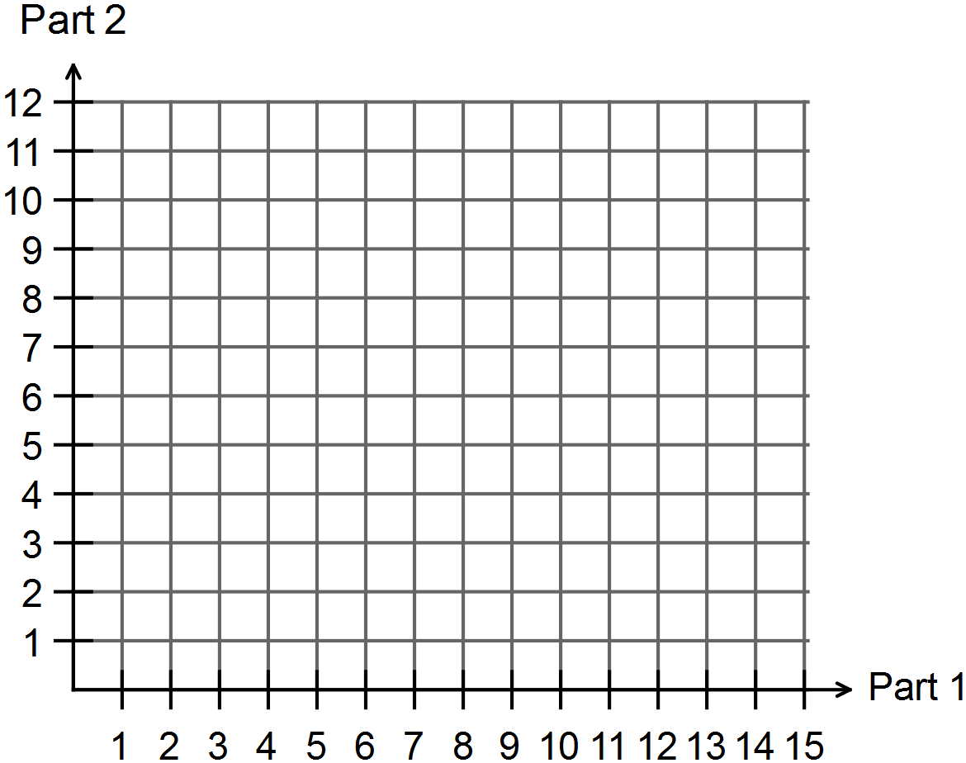

The regression line for the table data is

*Part 2 mark* = 1.31 + 0.64 × *Part 1 mark*

The coefficient of correlation, *r*, is 0.5224.

1. Use this equation to predict a Part 2 mark for a student who scored 13 in Part 1.

1. €Circle the point which represents the outlier.

(d) Remove the outlier for the data and calculate the new

1. correlation coefficient

1. equation for the regression line

e) Complete the following table by using the new equation to predict a Part 2 mark for each of the students listed. Using ‘I’ or ‘E’, indicate in the table whether the prediction is an interpolation or an extrapolation.

|  |  |  |
| --- | --- | --- |
| Part 1 | 13 | 5 |
| Part 2 |  |  |
| Interpolation or Extrapolation? |  |  |

(f) Which of the two predictions, for the Part 1 score of 13, is the more reliable (answer for part (b) or (e)? Justify your answer.

**~ END OF TEST ~**